OOPS
Different ways to initialize the object
1. by ref variable
2. by method
3. by constructor

Ways to create the object
1. new keyword
2.new instance()
3. by clone() method
4. by deserialization
5. by factory method

Anonymous object
As we know anonymous means which has no name
Simply object that has no reference

If you want to use object only once then we can use the anonymous object
Ex : new Calculator().fact(5);

Constructor:
It is similar to the method it is called when the instance of the class is created(object).
When object is created with new keyword at least one constructor is called.
When the constructor is called then only memory for the object gets created.
You don't need to define any constructor in the class directly java provides us the default constructor.

It is called as constructor because it constructs the value at the time of the object creation.

Rules for defining the constructor:

1. constructor name should be same as the class name
2. It should not have any explicit return type.
3. It should not be private, static or default and abstract

But you can use the access modifiers while defining the constructors to restrict the object creation.

Constructor overloading:
Having the two constructors with diff parameter list compiler differentiates based on the parameters.

Copy constructor in java

There is no copy constructor available in java but you can copy the values from one object to another object like in C++.

You can do it in three ways:
1.by using the constructor
2. by copying the values from one object to other
3. by clone() method of the object class

Constructor can perform object creation, starting a thread and also calling a thread.

We have constructor class in java:
We get the internal information of the constructor in java
which resides in the java.lang.reflect package.
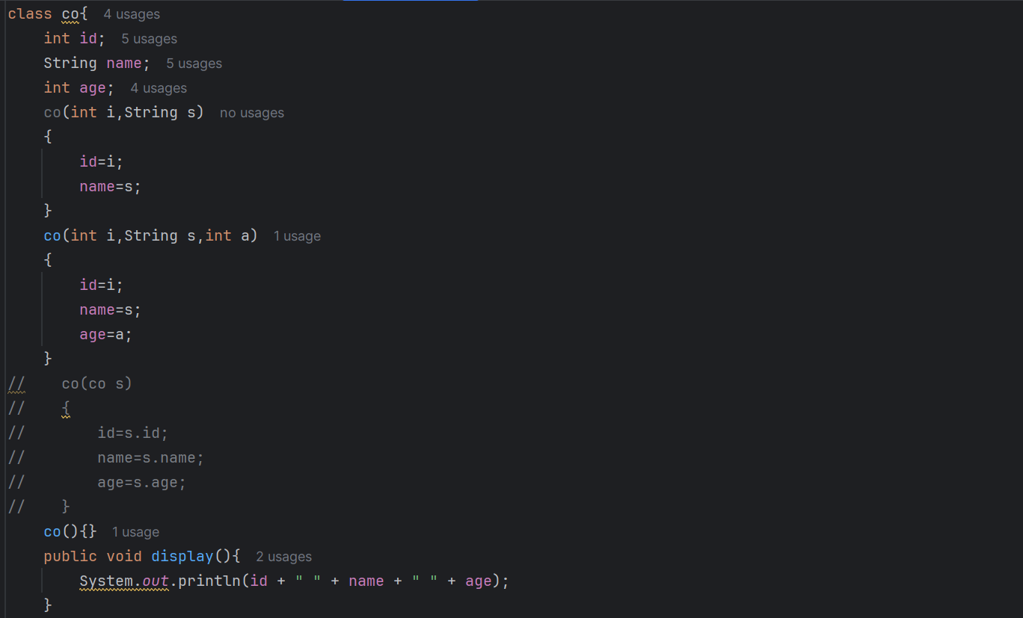
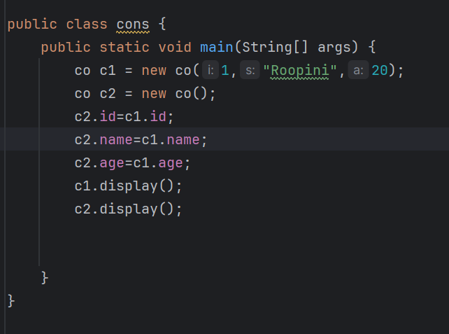

Static Keyword:
- Mainly used for the memory management.
- We can apply it for the variables, methods, blocks and also the nested classes.
- Static keyword is belongs to the class instead of the object .

Static variable:
-> Used to refer to the common property of all objects(Not unique for each object).
- Static variable only gets the memory once at the time of class loading.
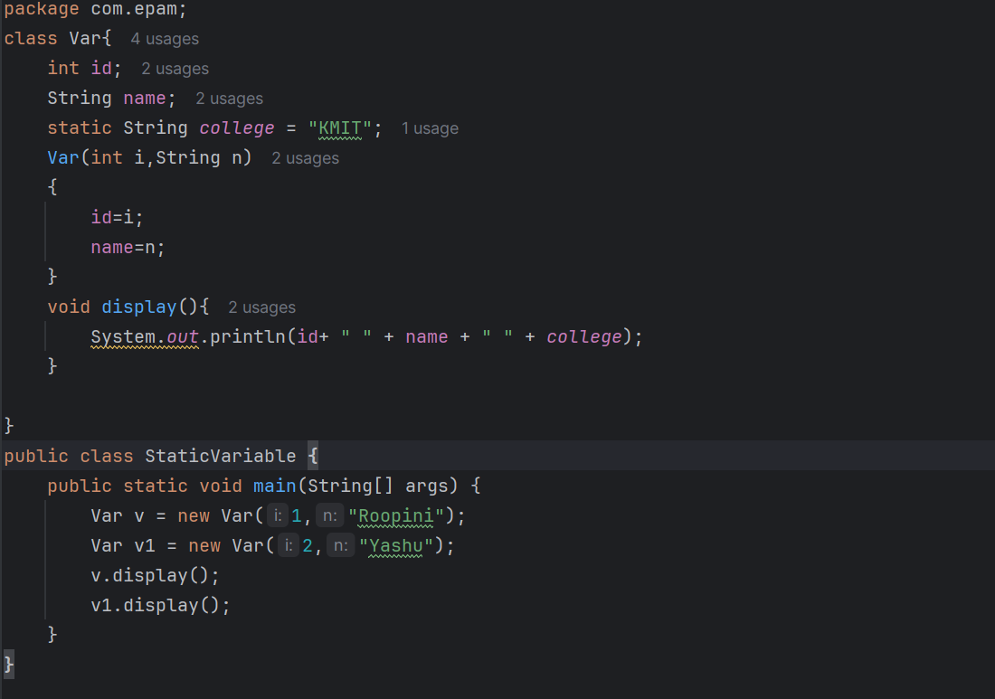
Static Method:
- Static method belongs to the class instead of the object of the class.
- Static method can be invoked without need for creating the object.
- It can directly access the static data member and can change the value of it.

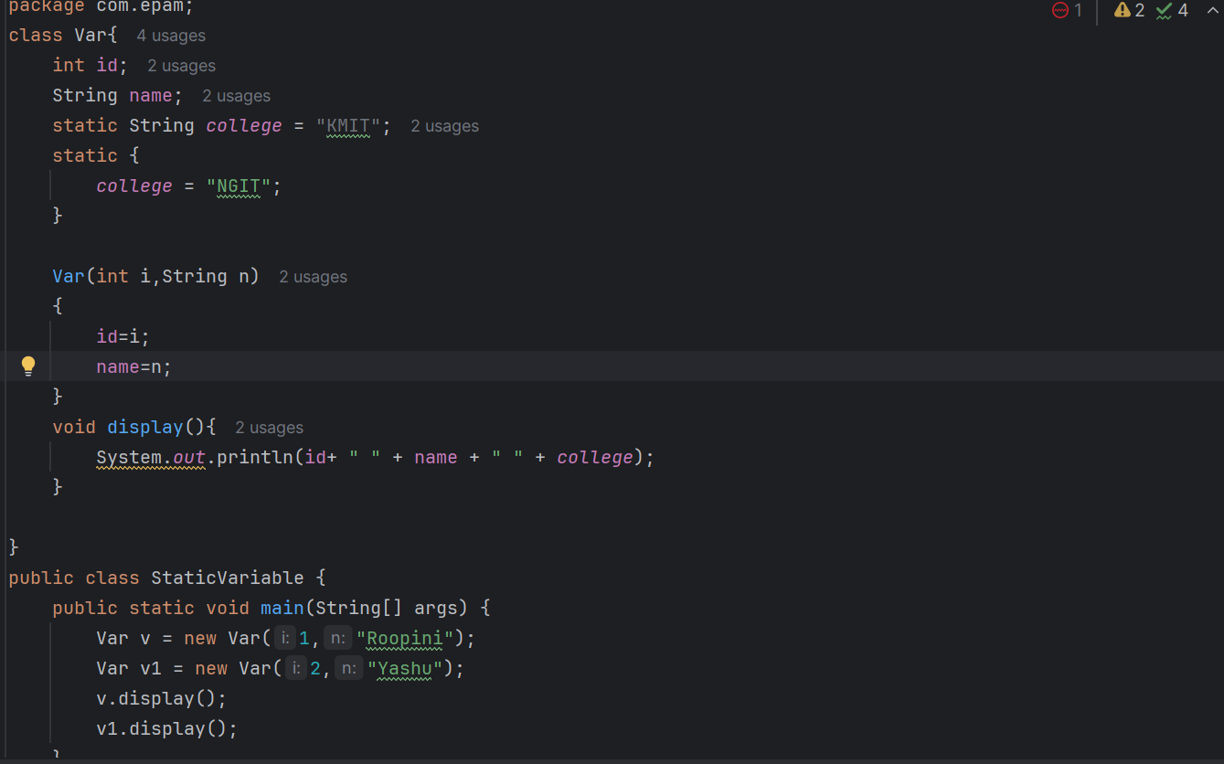

Restrictions for the static method:
- Static method cannot use the non static data member or it cannot directly access the non static data member.
- This and super cannot be used in static context.

Static block:
Initializes the static data member.
It executes before the main method gets executed at the time of the class loading.

This keyword:
- Ref variable Refers to the current object.
- 1. Used to refer current class instance variable.
- 2. To invoke current class method.
- 3. To invoke current class constructor(Constructor chaining).
- This constructor call is mainly used to reuse the constructor from the constructor. Maintains the chain between the constructors.
- Rule: Call to this() must be the first statement in constructor.
- You can pass this keyword as an argument in the metho.
Inheritance:

- Mechanism where one object acquires all the properties and behaviours of the parent object.
- Has IS-A Relationship(called as parent child relationship).
- Main advantage is code reusability. You will reuse the fields and methods that are already defined in the previous class.
- We use extends keyword to inherit from parent class to child class.
- Single inheritance: A->B
- Multilevel inheritance: A->B->C
- Hierarichal inheritance : A<-(B,C)
- Multiple inheritance is not supported in java because of ambiguity.
Aggregation:
It is independent and does not depend on any class.
It has a HAS-A relationship.
Code reusability.

Polymorphism:
- Compile time polymorphism
- Method overloading
- Run time polymorphism
- Method overriding.
Method overloading:
Method having the same name with the different type of parameters.
If we want to perform only one operation we can go for using the method overloading so that readalibility increases.
Ways to overload the method
- By changing the arguments
- By changing the data type
Restrictions:
We cannot change the return type of the method when overloading it is not possible because of ambiguity (We will get the compile tune error).

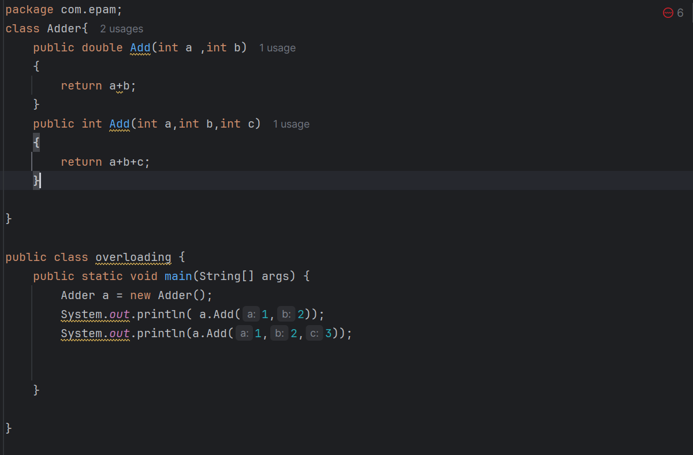
Type promotion:
One type can be promoted into the other implicitly if no matching datatype is found.
Short-> int, long, double,float;
Byte->short,long,double,int or float
Char->int, long,double or float.
One type is not de-promoted implicitly for example double cannot be depromoted to any type implicitly.

Method overriding:

- If the subclass has the same method name and same no of parameters as the parent class. It is known as the method overriding.
- Run time polymorphism.
- Basically it provides the specific implementation of a method which is already provided by its superclass.
- It need to have a IS-A relationship.
We cannot override a static method because it is bound with class where as instance method is bound with the object. And the other thing is static belongs to class area and the instance belong to heap area.
Covariant Return type(Most Most important concept).
It is defined as changing the return type of the subclass.
Before java 5 it is not possible to override a method by changing the return type but from java5 it is possible when the subclass override a method that return the non-primitive and it changes its return type to the subclass type it is called as covariant return type.
class Parent {
public Number getValue() {
return 42;
}
}

class Child extends Parent {
// Correct: Covariant return type (Integer is a subclass of Number)
@Override
public Integer getValue() {
return 42;
}
}

public class Test {
public static void main(String[] args) {
Parent p = new Child();
System.out.println(p.getValue()); // Calls Child's method, prints 42
}
}

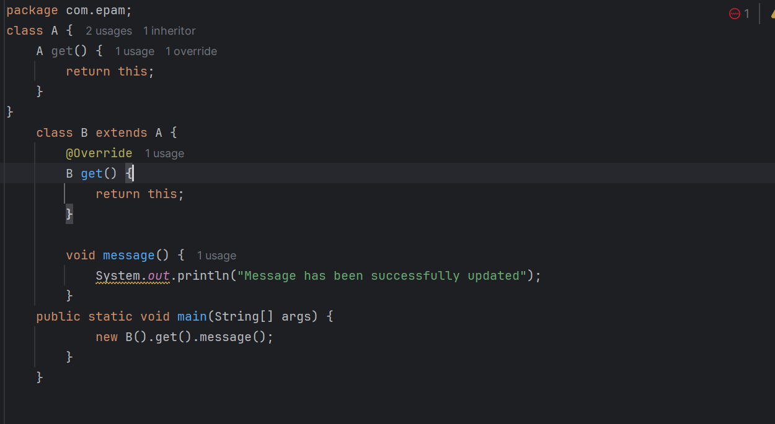

Super Keyword:

- It is also a reference variable which is used to refer the immediate parent class object.
- Whenever you create a instance of the subclass a instance of the parent class is created implicitly which is referred by super reference variable.
- We can use super keyword in three ways.
- 1. Refer to immediate parent class instance variable
- 2. Parent class method
- 3. Parent class constructor.

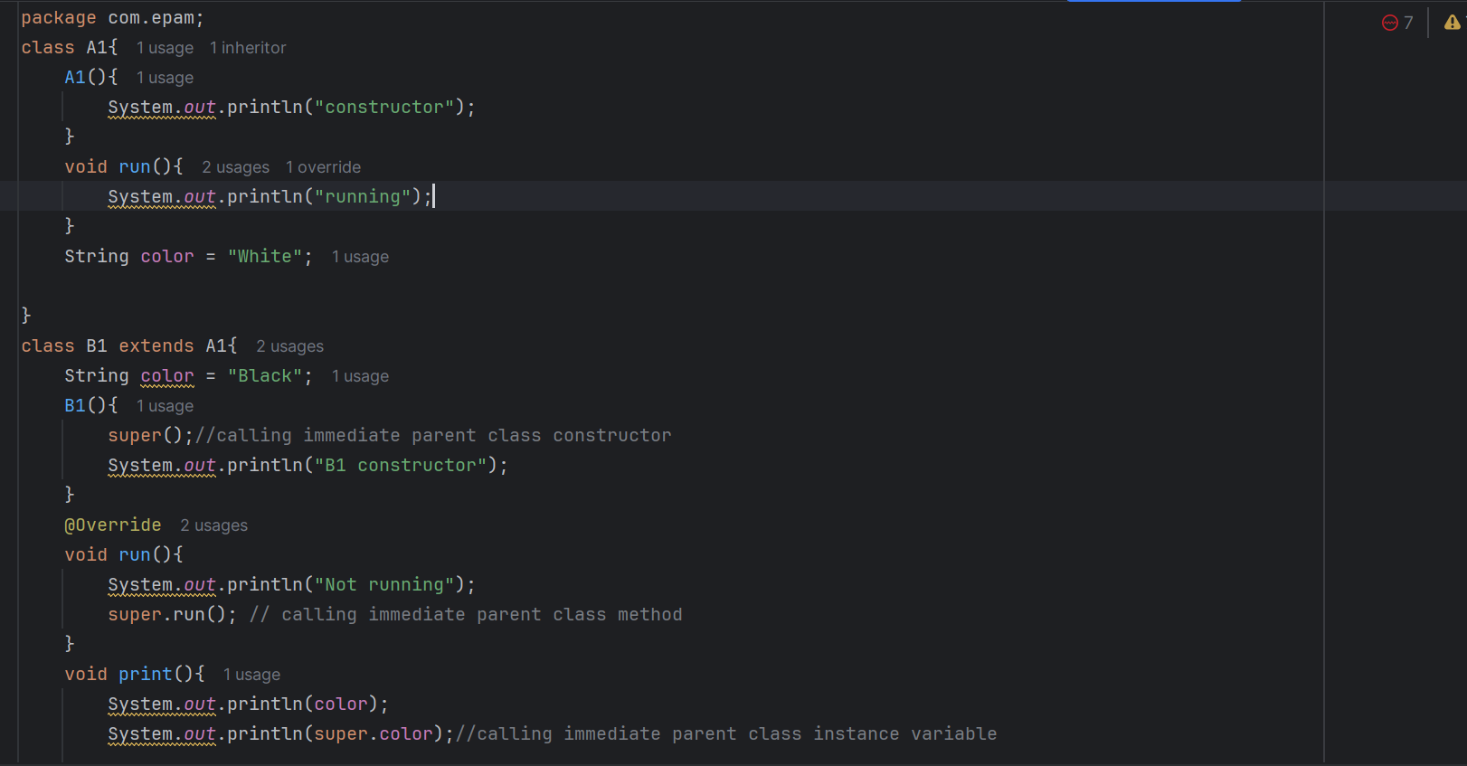

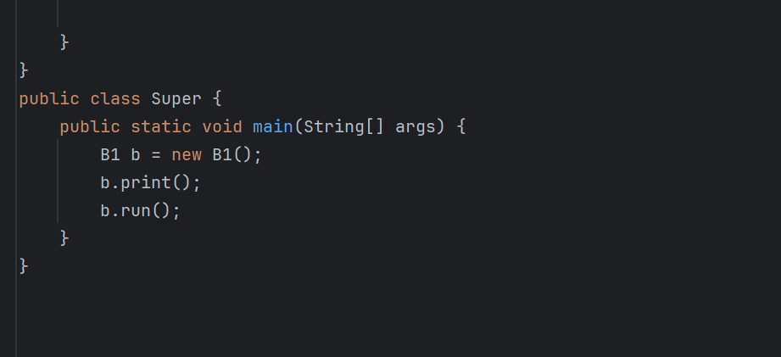

Final Keyword:
- Mainly used to restrict the user.
- It can be applied to variables, methods and classes

Java Final Variable:
- If you define a variable as final you cannot change the value
- You cannot override it.
- You cannot inherit it.

Java Final Method:
- Once you declare variable as final you cannot override it.

Java Final Class
- Once you define a class as final you cannot extend it.
The variable which is not declared at the time of initialization is called as blank final variable.
We can initialize the blank final variable but only possible in the constructor.
Static blank final variable:
Variable which is not declared at the time of initialization is called as static blank final variable.
We can only initialize It in the static block.
And also constructor is never be final because it is never inherited. 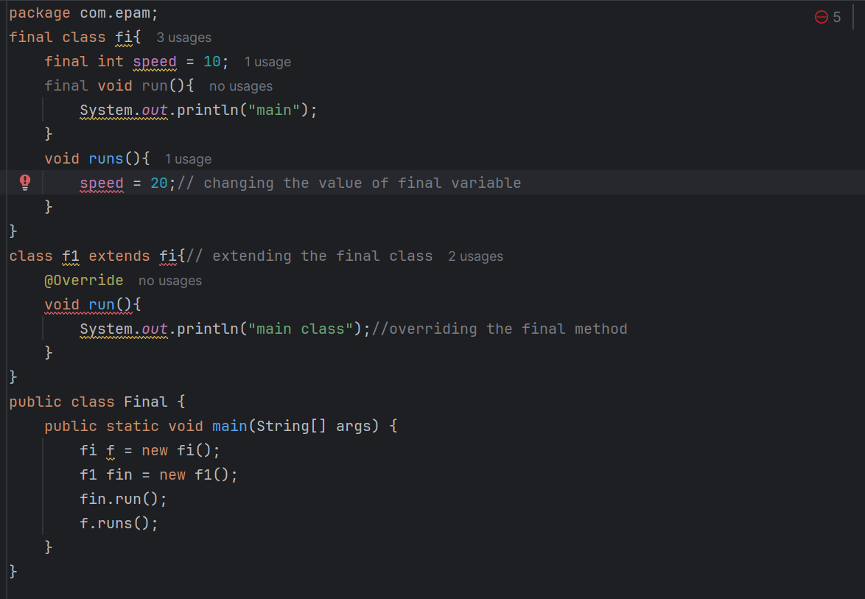

Runtime Polymorphism:
- As we know polymorphism means single action can be performed in different ways.
- Poly means many and morphs means forms
- It is also called as dynamic method dispatch because the overridden method call is resolved at the runtime rather than the compile time.
- Upcasting: Reference variable of parent class and the object of the child class.
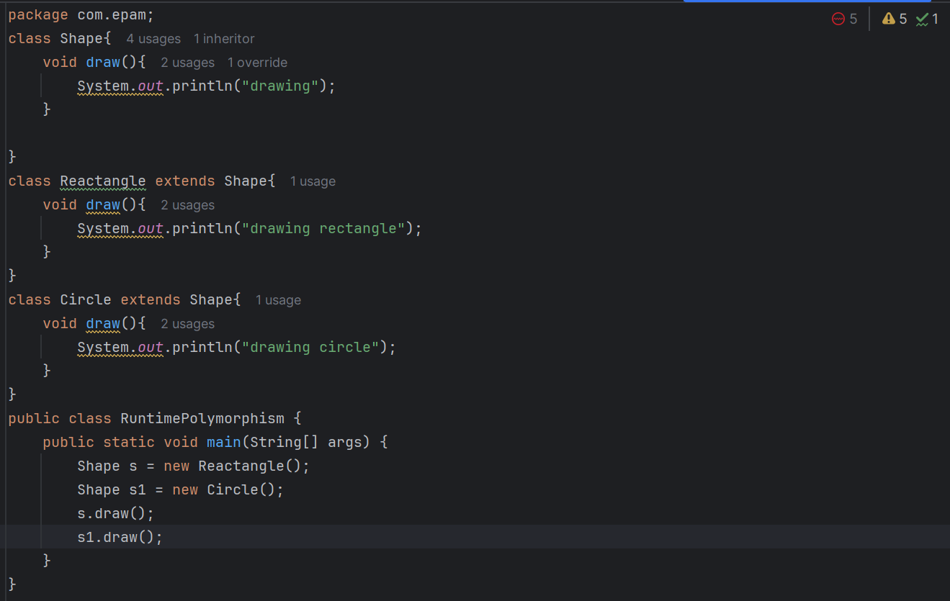
Binding:
Connecting a method call to a method body is called as binding.
- Static binding: When the type of the object is known at the compile time it is called as static binding. Ex: if the method has private, static fields we can say it is a static binding.
- Dynamic binding: when the type of the object is not known at the compile time is known as dynamic binding.
Instance of Operator:
It is used to test whether the object is an instance of the specific type or not.
Basically used to compare the instance with type.
- class Simple1{
- public static void main(String args[]){
- Simple1 s=new Simple1();
- System.out.println(s instanceof Simple1);//true
- }
- }

Abstraction:
Process of hiding implementation details and showing only functionality to user is know as abstraction.
We can achieve abstraction using two methods:
- Using abstract classes
- Using interfaces(Complete abstraction).
Abstract class:
The class which is declared with abstract keyword
Abstract class can contain abstract and non abstract methods.
Cannot be instantiated
Can have constructors and static methods too.
Can have final methods so that subclass cannot change the method body.

Abstract method:
Method declared with abstract keyword
This abstract method has no body and implementation.
If you declare the method as abstract you need to provide the implementation for that method in the subclass .
If you have not provided the method implementation in the subclass you need to make that class as abstract.
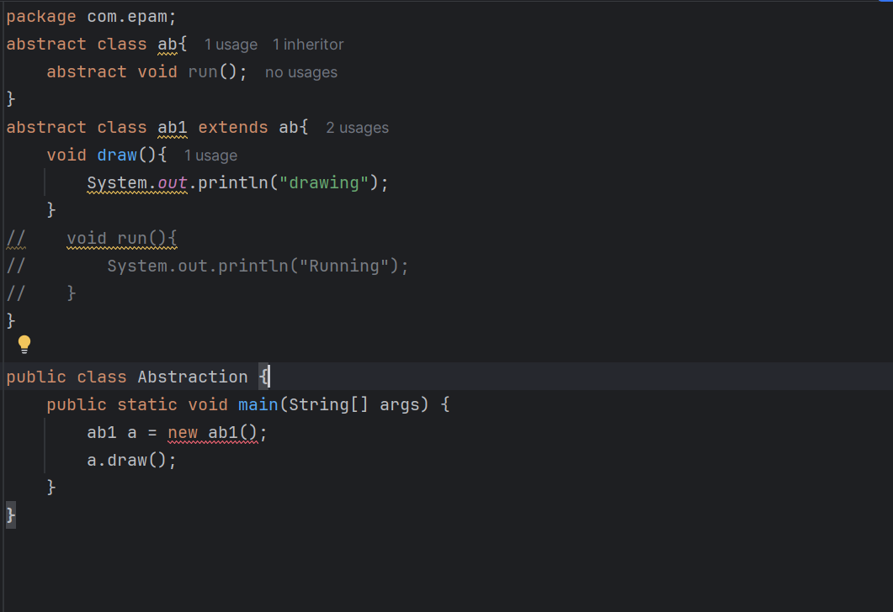

Interfaces:
It is a blueprint of a class.
Contains static and constant methods.
It has IS-A relationship.
And also it does not contains non abstract methods. So each method should be implemented in the respective subclasses or else we will make the subclass as abstract.
From java 8 interfaces can have the static and default methods
From java 9 they can have private methods too.
- Most usage of interfaces are:
- To achieve abstraction .
- Support the functionality of the multiple inheritance
- To achieve loose coupling.
Interface can be declared using the interface keyword. All the methods in the interface are declared with the empty body and all the methods are public, static and final by default.
You need to implement all the methods.
The Java compiler adds public and abstract keywords before the interface method. Moreover, it adds public, static and final keywords before data members.
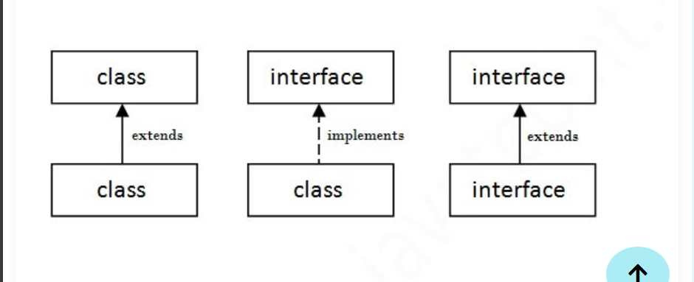
Multiple inheritance using interfaces:
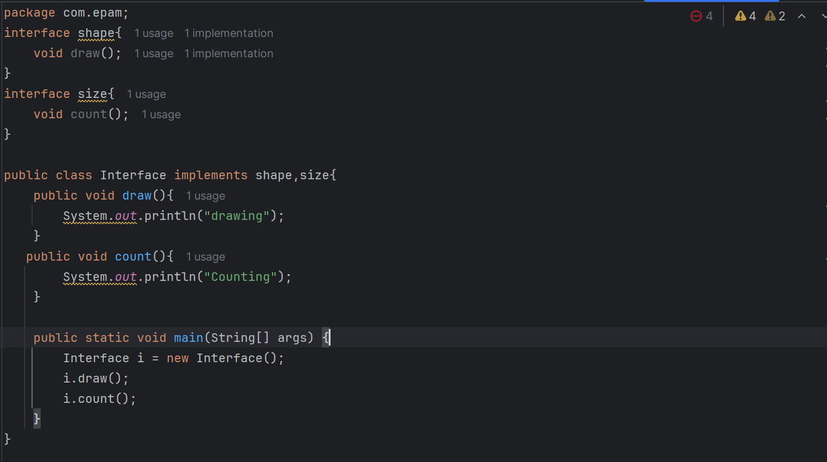

Interface inheritance:
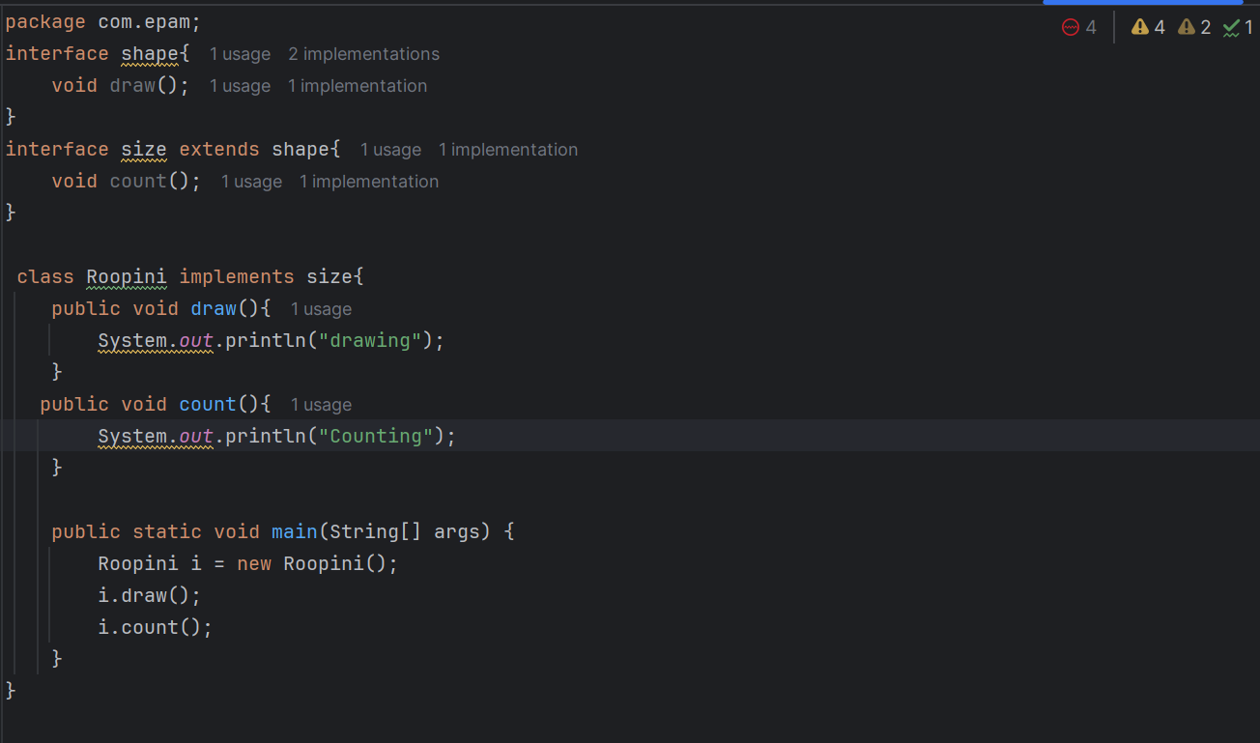
Q) What is marker or tagged interface?
An interface which has no member is known as a marker or tagged interface, for example, Serializable, Cloneable, Remote, etc. They are used to provide some essential information to the JVM so that JVM may perform some useful operation.
- //How Serializable interface is written?
- public interface Serializable{

Access modifiers in java:
It is basically used to define the scope or availability of the fields, methods and also the constructors.
We can change the access level of the fields, constructors by applying the access modifiers on them.
There are totally 4 access modifiers are available in java:
Private : access level is only within class
Default : access level is within the package.
Protected : access level is within the package and also the outside of the package through child class. If child class is not there we cannot access it from outside of the package.
Public : access level is everywhere.
There are many non-access modifiers, such as static, abstract, synchronized, native, volatile, transient, etc.
A class cannot be private or protected except nested class.
Role of Private Constructor
If you make any class constructor private, you cannot create the instance of that class from outside the class
Protected data member cannot be applied to the class.
Provides more accessibility than the default access modifier.

Encapsulation:
It is a process of wrapping code and data together as a single unit.
By providing only a setter or getter method, you can make the class read-only or write-only. In other words, you can skip the getter or setter methods.
It is the way of achieving the data hiding because other class will not be able to access the data through the private data members.
The encapsulate class is easy to test. So, it is better for unit testing.
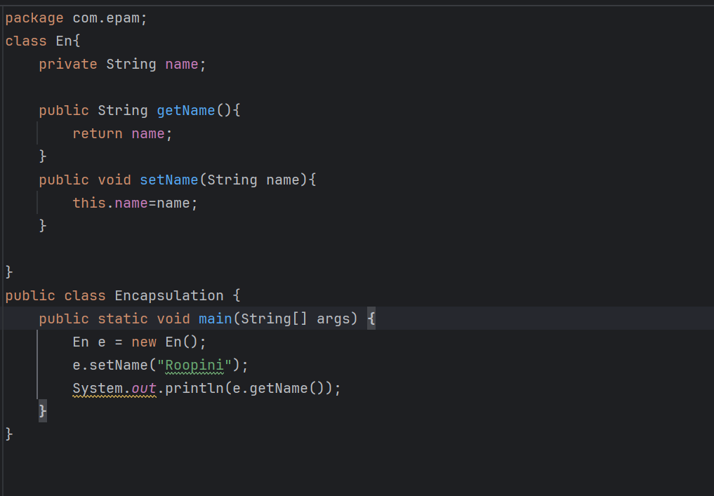

Object cloning:
Creating the exact copy of the object using the clone() method of the object class.
Java.lang.Clonable interface must be implemented by the class whose object clone we want to create.
If we don’t implement clonable interface clone() method generated us CloneNotSupportedException.
